PSYCHOLOGY 5
MIDTERM EXAM 1
RAY GRIMM, Ph.D

Name: ________________________________________

Multiple Choice
- A U.S. Senator from Indiana wanted to know what all her constituents thought about the Clean Air Act that was coming up for a vote in the Senate. She sent a letter to a sample of 257 Indiana voters asking them if they supported the Clean Air Act even if it meant they would have to pay higher prices for gasoline. The results indicated that 39% of the sample supported the Clean Air Act even if it meant higher gasoline prices. The purpose of this survey is best described as ______:
  - descriptive
  - inferential
  - sampling error
  - parameter

- Is the number of students registered for a Statistics course continuous or discrete or neither? a. continuous
  - discrete
  - neither

- A teacher records the number of class days each student misses over the course of a semester. How many people missed 5 classes?
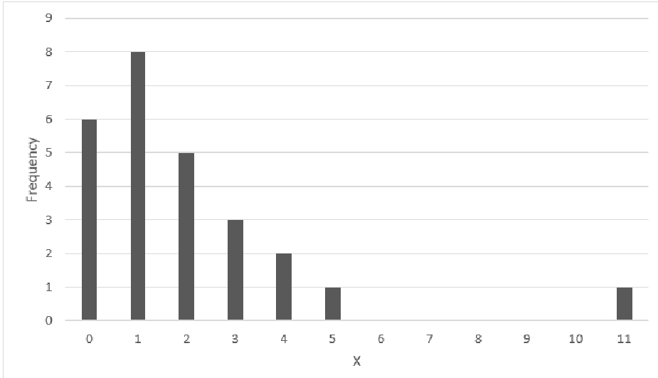
  - 2
  - 4
  - 6
  - 1

- A cognitive psychologist studying reading comprehension wanted to know what would happen if all college students were taught better reading strategies. She obtained a sample of 40 college students from the introductory psychology class and taught 20 of them effective reading strategies. The other 20 students were given a placebo treatment. She then gave all 40 students a standardized reading comprehension test. The mean score on the reading test for those taught the reading strategies was 49, with a standard deviation of 4. The mean score for those receiving the placebo treatment was 44, with a standard deviation of 3.8. Identify the dependent variable in this study.
  - scores on the reading comprehension test
  - the sample of 40 college students
  - the reading strategies class
  - the treatment group (placebo or reading strategies)

- You ask the person who teaches your English class their academic rank (e.g., instructor, assistant professor, associate professor, full professor). Identify the scale of measurement for the underlined variable. a. nominal
  - ordinal
  - interval/ratio
  - orthogonal

- The following frequency table was created from peoples’ responses to the question, “how much do you like country music?” on a scale of 1–9 (1 = not at all and 9 = a lot). What score is the mode of this distribution?
X |  | Frequency | Percent | Valid Percent | Cumulative Percent
 | 1.00 | 4 | 20.0 | 20.0 | 20.0
 | 2.00 | 2 | 10.0 | 10.0 | 30.0
 | 3.00 | 5 | 25.0 | 25.0 | 55.0
 | 4.00 | 1 | 5.0 | 5.0 | 60.0
 | 5.00 | 3 | 15.0 | 15.0 | 75.0
 | 6.00 | 2 | 10.0 | 10.0 | 85.0
 | 7.00 | 3 | 15.0 | 15.0 | 100.0
 | Total | 20 | 100.0 | 100.0
  - 1
  - 2
  - 3
  - 4
  - 5

- The data in the following table came from the question, “On a scale of 1–6 (1 = not at all and 6 = a lot), how much do you like eating yogurt for breakfast?” What score is the median of this distribution?
X | f | Percent | Cumulative frequencies | Cumulative percentages
6 | 3 | 30 | 10 | 100
5 | 4 | 40 | 7 | 70
4 | 2 | 20 | 3 | 30
3 | 1 | 10 | 1 | 10
2 | 0 | 0 | 0 | 0
1 | 0 | 0 | 0 | 0
  - 2
  - 3
  - 4
  - 5
  - 6

- You asked several classmates how many times they texted their parents over the weekend. Utilizing the formula for the mean, compute the mean of these sample data. Show your work.

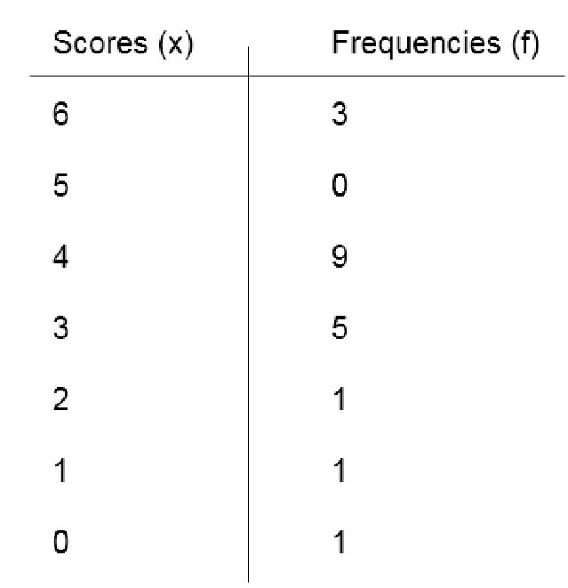
  - 3.38
  - 3
  - 3.6
  - 3.14

- Which measure of central tendency should you use in the following situation? You asked students to guess how old Professor Youngblood is and obtained the following data:

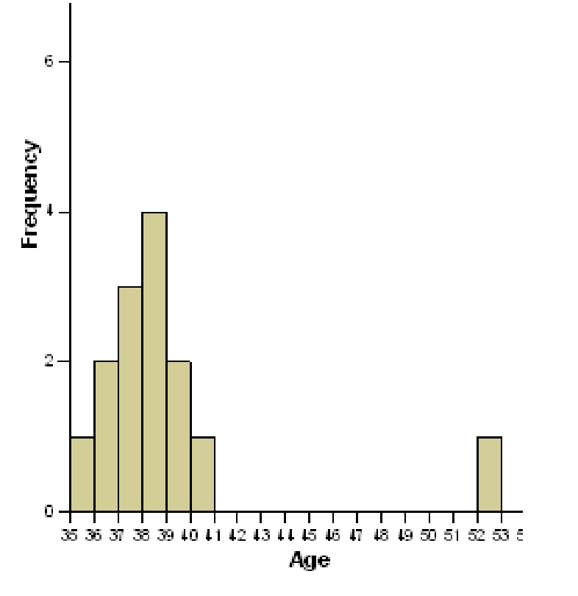
  - mode
  - median
  - mean

- A positive deviation score means that:
  - the raw score was above the mean.
  - the raw score was below the mean.
  - the mean was negative.
  - the mean was positive.

- What is the sum of the deviation scores for the data in the frequency distribution table below?
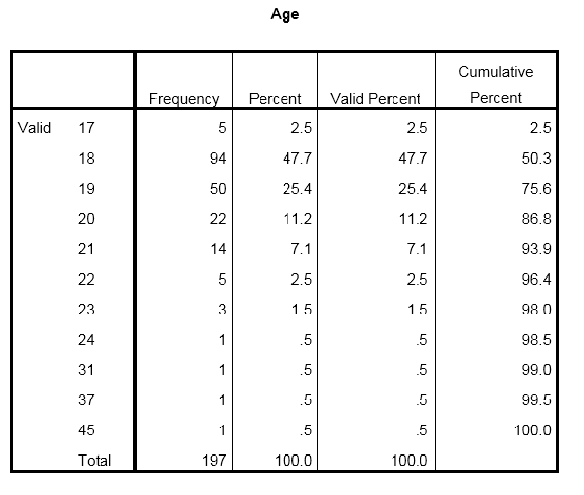
  - 100
  - 0
  - 197
  - 1

- A researcher wanted to know if waitresses who smile and touch their customers on the shoulder get bigger tips than waitresses who don’t. The research had a waitress smile and touch the shoulder of half of her customers and did not smile or touch the shoulders of her other customers. The fact that some people ordered more expensive meals than others contributes to the ______ in this study.
  - measurement variability
  - treatment variability
  - individual differences variability
  - parametric variability

- Which of the following is an accurate description of what the standard deviation is measuring? The standard deviation measures:
  - The typical deviation between scores in a distribution and the mean of that distribution.
  - The typical deviation between sample means and population means.
  - The typical deviation between scores.
  - The typical distance between the sample standard deviation and the population standard deviation
- Which of the following two graphs has more variability? Choose A, B or same.

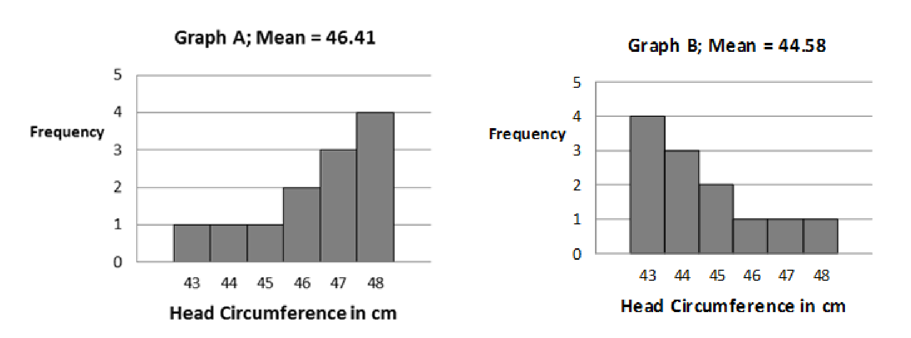 a. Graph A has more variability
  - Graph B has more variability
  - Same amount of variability

- A sleep researcher is interested in the number of hours of sleep her patients got the previous night. Below are data from 15 of her patients rounded to the nearest hour.
1, 5, 3, 4, 5, 3, 6, 5, 4, 3, 4, 5, 3, 5, 4
Using the computational formula, what is the SS for this population of scores? Show your work.

a. 1.25
  - 262
  - 1.57
  - 4.18
  - 22

Scenario to be used for Problems 16 - 19
Dr. Castaneda is interested in the effect of acts of kindness on people's experience of empathy. He recruits 50 participants and randomly assigns them to two groups. Both groups receive twenty-five dollars. The first group is told that they can spend the money on whatever they would like for themselves. The second group is told to use the money to help someone else. After a week, both groups complete an Empathy scale. Each question of the Empathy scale is scored from 1 -10 with high scores representing High empathy and low scores representing little or no empathy. All scores are averaged to get a final empathy score that ranges from 1 to 10. . The following frequency distribution tables details Dr. Castaneda’s results.

Scores on Empathy Scale
Self-serving Act |  |  | Kindness to Other Act
X | f |  | X | f
10 | 1 |  | 10 | 7
9 | 2 |  | 9 | 5
8 | 4 |  | 8 | 5
7 | 7 |  | 7 | 2
6 | 4 |  | 6 | 3
5 | 3 |  | 5 | 1
4 | 2 |  | 4 | 1
3 | 1 |  | 3 | 1
2 | 0 |  | 2 | 0
1 | 1 |  | 1 | 0

- What is(are) the Independent Variable (IV), Conditions (C), and Dependent Variable for this study?
  - IV is Empathy Score; C is Self-serving act and Kindness to other act; DV is Type of Act performed
  - IV is Type of Act performed; C is Self-serving act and Kindness to other act; DV is Empathy Score
  - IV is Self-serving act and Kindness to other act; C is Empathy Score; DV is Type of Act performed
  - IV is Type of Act performed, C is Empathy Score and DV is Self-serving act and Kindness to other act

- Use StatCrunch to compute the mean, median, mode, sample standard deviation (SD) and sample variance (SD²) for the Self-serving Act group. The mean, median, mode, SD, and SD² respectively for the Self-serving Act group are: (Attach your StatCrunch table to get credit for this problem.)
  - 5.48, 6, 7, 2.49, 6.18
  - 6.4, 7, 7, 1.98, 3.92
  - 7.96, 8, 10, 2.01, 4.04
  - 6.4, 7, 7, 2.02, 4.08

- Use StatCrunch to compute the mean, median, mode, population standard deviation (𝜎) and population variance 𝜎² for the Kindness to Other Act group. The mean, median, mode, 𝜎, and 𝜎² respectively for the Kindness to Other Act Group are: (Attach your StatCrunch table to get credit for this problem.)
  - 7.96, 8, 10, 1.97, 3.88
  - 7.72, 8, 10, 2.20, 4.84
  - 7.96, 8, 10, 2.01, 4.04
  - 7.72, 8, 10, 2.25, 5.04

- Use StatCrunch to construct a bar graph for Kindness to Other Act group. Which is the correct graph? a.
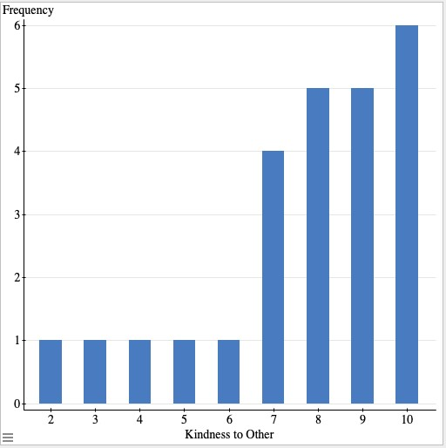
b.
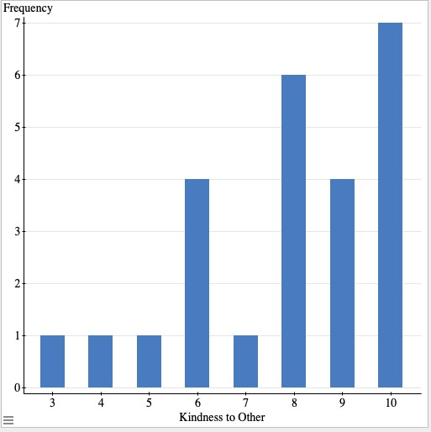
c.
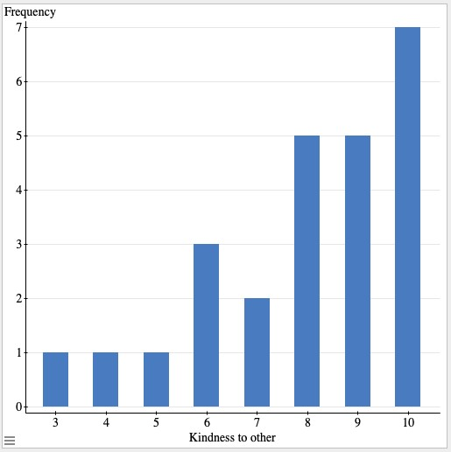

- Compute the standard deviation for this population of scores using the Computational Formula. Show your work.
20, 6, 8, 26, 29, 30, 14
  - 9.15
  - 9.88
  - 97.61
  - 84.27
  - 586

- Compute the standard deviation for this sample of test scores using the Computational Formula.. Show your work.
X | f
90 | 6
80 | 3
70 | 5
60 | 0
50 | 2
  - 548.75
  - 182.92
  - 13.52
  - 14.2

- After taking the SAT, a student learns that he was at the 45th percentile. What do you know about his z score? a. it is equal to 45
  - it is equal to zero
  - it is positive
  - it is negative

- Which of the following z scores is closest to the population mean?
  - 1.87
  - 1.07
  - −1.50
  - −0.56

- Aiden receives a z score of −.3 on an exam that is normally distributed, what percentage of the students did worse than Aiden?
  - 30%
  - 70%
  - 61.79%
  - 38.21%

- The average height of men in the United States is 70 inches with a standard deviation of 4 inches. What proportion of men are 6 feet (72 inches) or taller? Show your work.
  - .1587
  - .8413
  - .6915
  - .3085

- A college admissions officer needs to determine which of two students should receive a scholarship. In part, the scholarship is based on standardized test score from tests of fluency in a foreign language. In this case, one student took the Spanish Fluency Test (SFT) and the other took the German Fluency Test (GFT). Use the information below to determine who did better on the standardized test. Compute the students’ z score for the SFT and the GFT. Show your work.
 | Mean on Test | Standard Deviation on Test | Student’s Test Score
Student A (took the SFT) | 50 | 10 | 62
Student B (took the GFT) | 115 | 20 | 120
  - SFT z = 1.2; GFT z = −.25
  - SFT z = −1.2; GFT z = −.25
  - SFT z = 1.2; GFT z = .25
  - SFT z = .65; GFT z = −.79
  - SFT z = .65; GFT z = .79

- Harriet wants to know if she is better at History or Cognitive Psychology. In order to answer this question she compiled the following information from her last exam in each of these courses. Use the information below to determine in which course Harriet performed better, History or Cognitive Psychology. What were Harriet’s z scores for the History exam and the Cognitive Psych Exam? Show your work
Topic | Mean on Test | Standard Deviation on Test | Harriet’s Score on Test
History | 70 | 14 | 69
Cognitive Psych | 55 | 9 | 65
  - History Exam z = −.70, Cognitive Psych exam z = −1.11
  - History Exam z =.07, Cognitive Psych exam z = −1.11
  - History Exam z = −.70, Cognitive Psych exam z = 1.11
  - History Exam z = -.07, Cognitive Psych exam z = 1.11
  - History Exam z = −.07, Cognitive Psych exam z =−1.11

- Scores on a test of reading ability for second graders are normally distributed with a mean of 60 and a standard deviation of 11. The principal of a school wants to identify the students who are in the bottom 15% of the class so that they can receive extra help in reading. What test score is the cut off for the bottom 15% of the class? Show your work.
  - 48.56
  - 45.00
  - 58.96
  - 49.82

